**EXPERIMENT-3 ZOHO**

LIBRARY BOOK RESERVATION SYSTEM

STEP-1 : GO to ZOHO Creator and build the app for Car Reservation

System

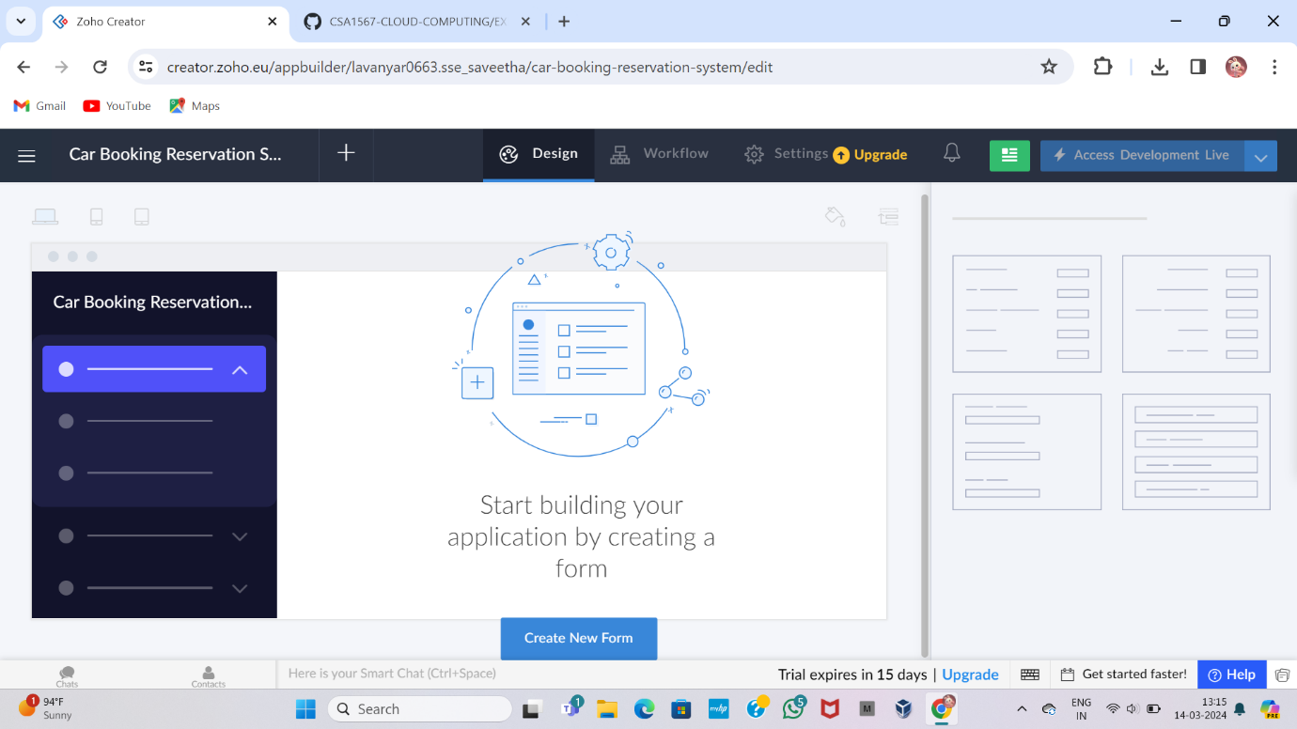

STEP-2 : Click the add new icon displayed at the top of the Design

Page

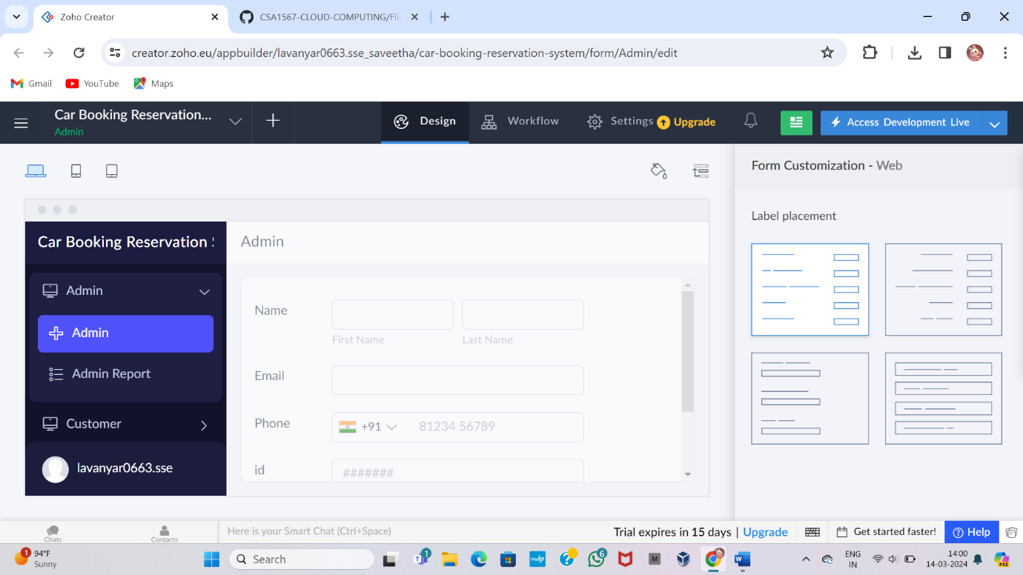

STEP-3 : Select blank and enter a name of the form, then create new form

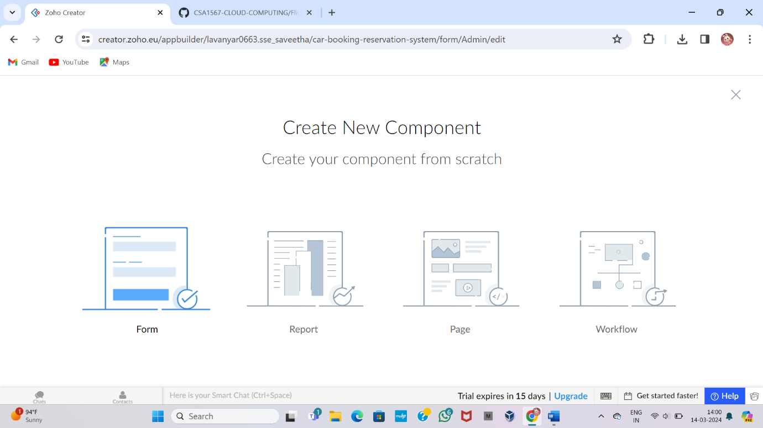

STEP-4 : It will be created to the newly created form’s builder

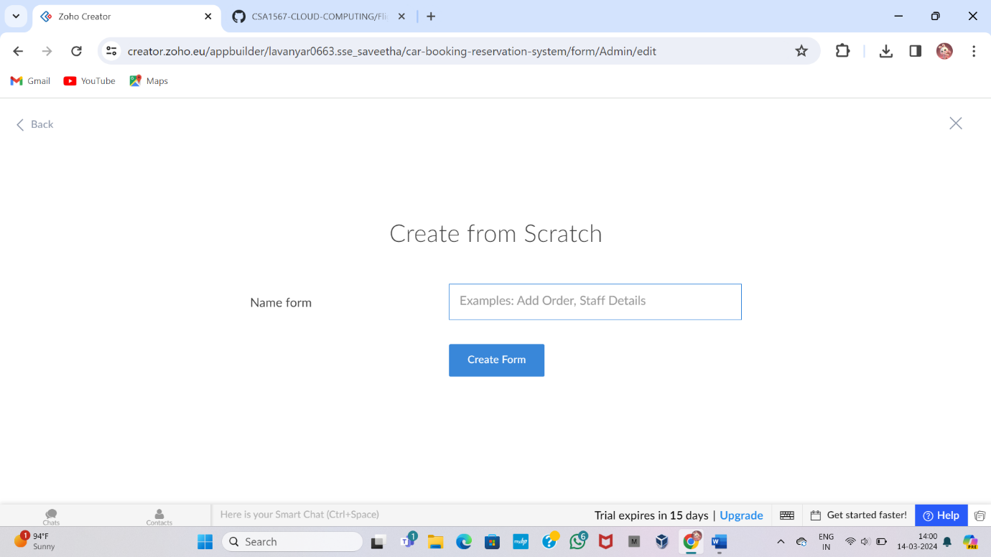

STEP-5 : Create a Member Form and Enter the Details

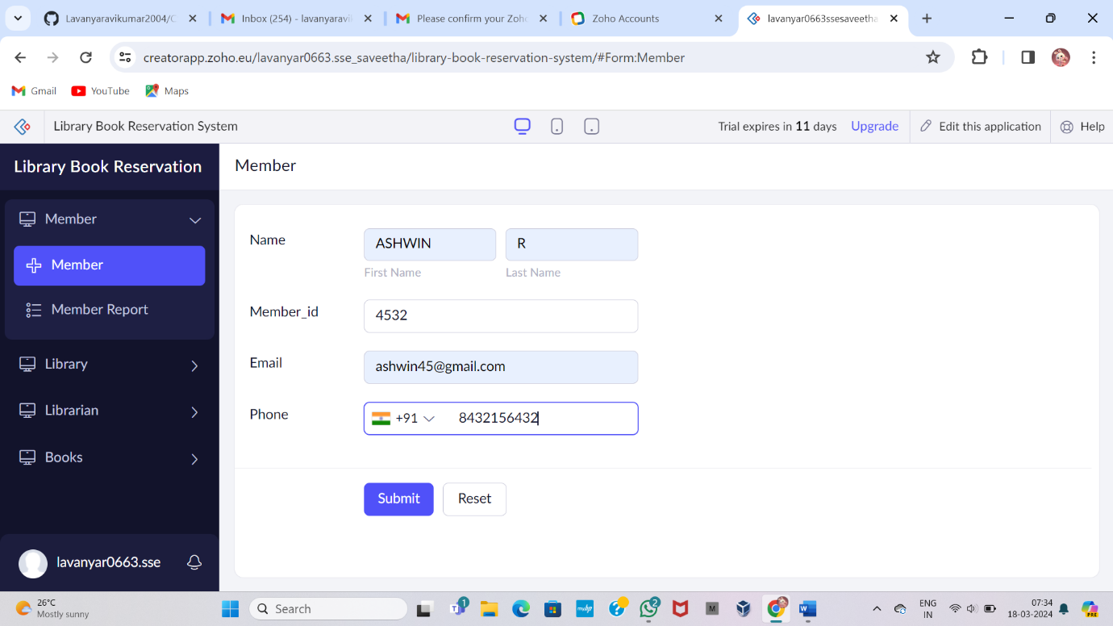

STEP-6 : Addon with that create a Library form and again fill those details

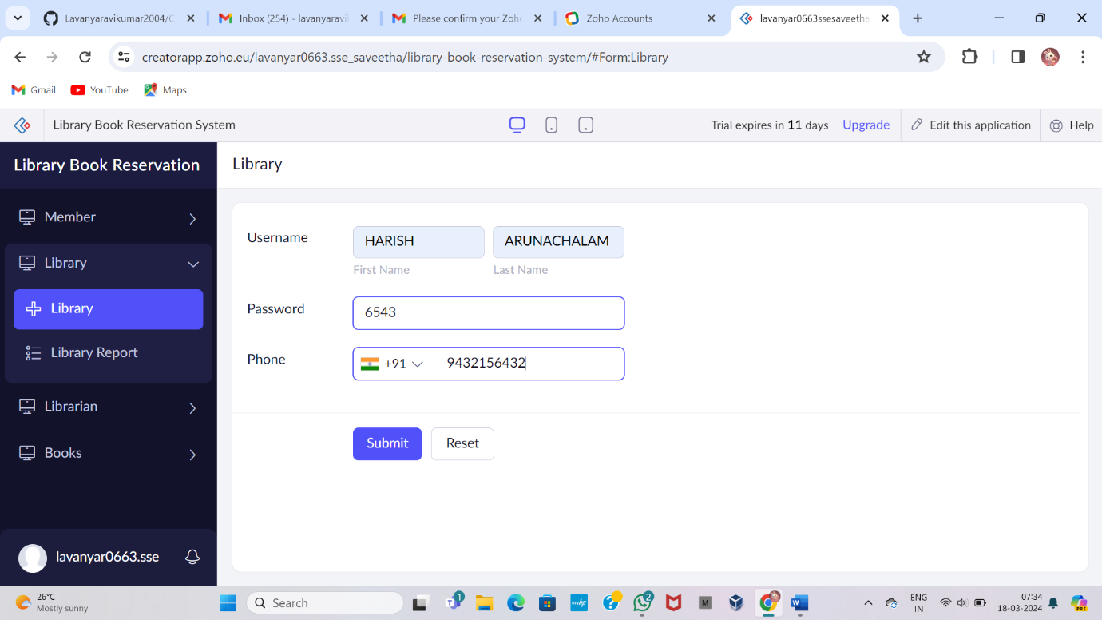

STEP-7 : Additionally, type the Librarian form and fill the details

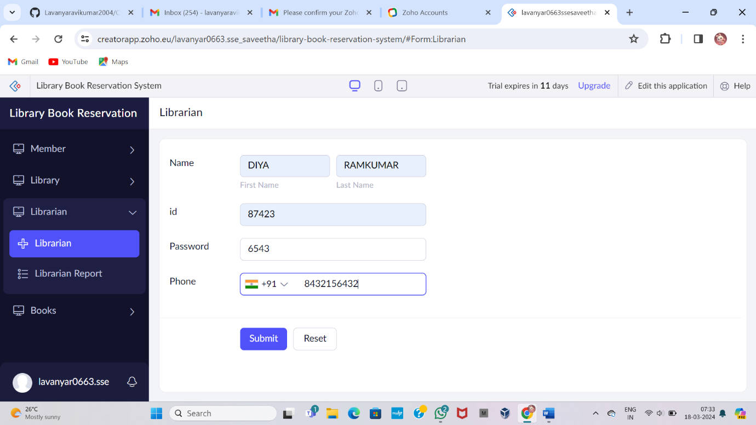

STEP-8 : Create Books field and enter the details

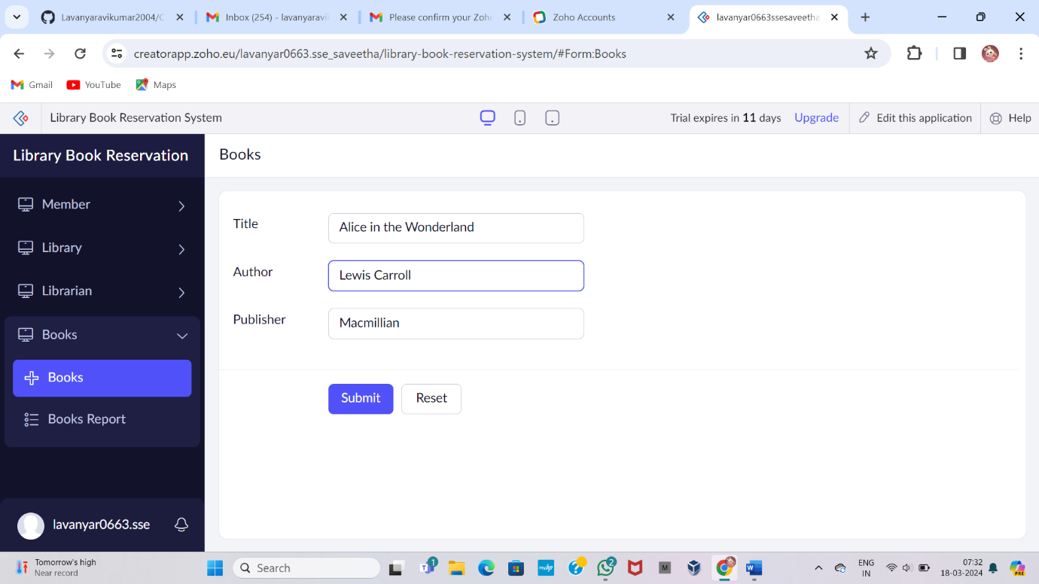

STEP-9 : Display the Member details

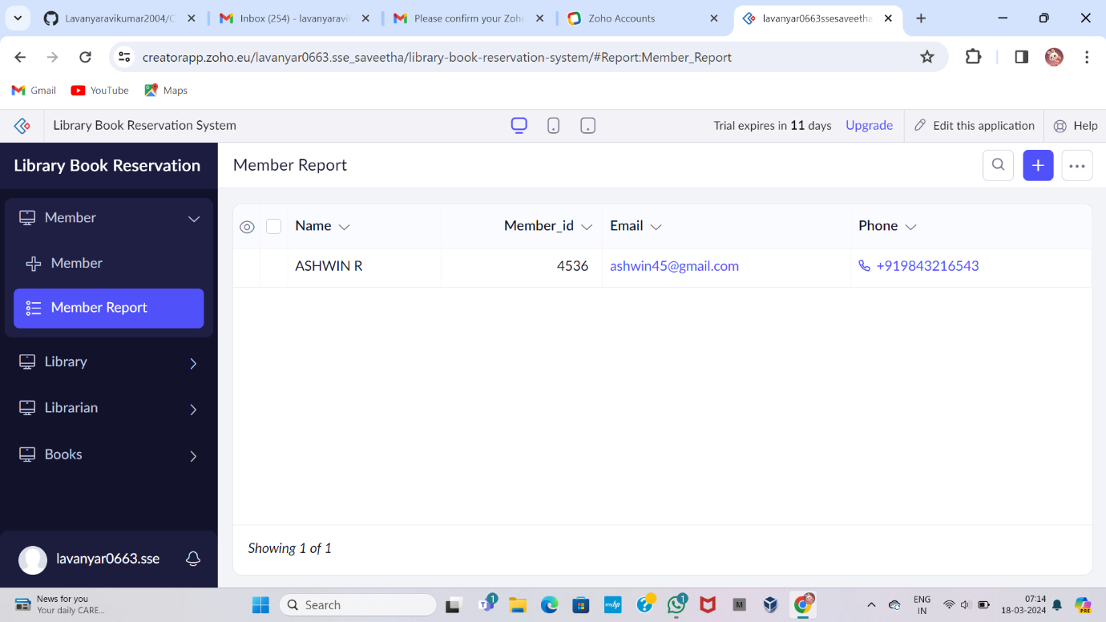

STEP-10 : Display the Library details

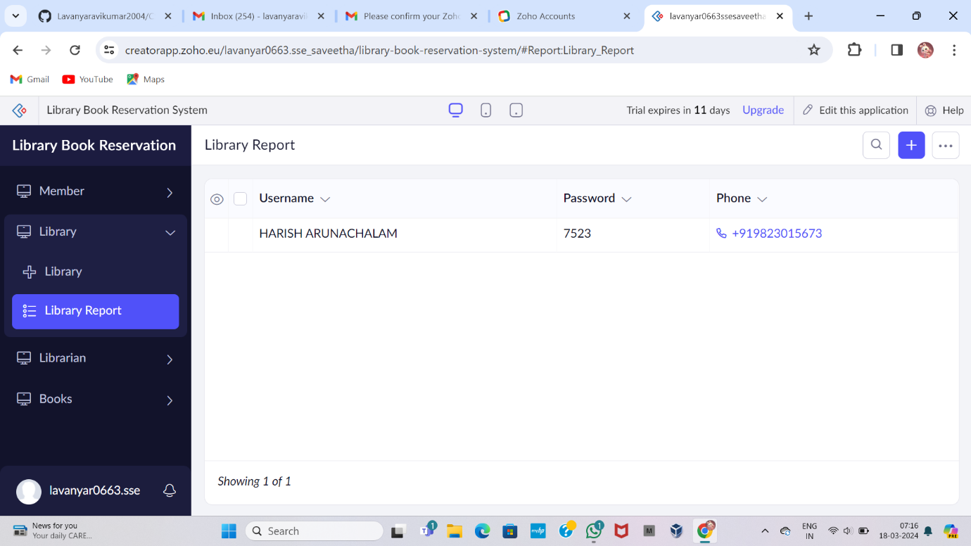

STEP-11 : Display the Librarian details

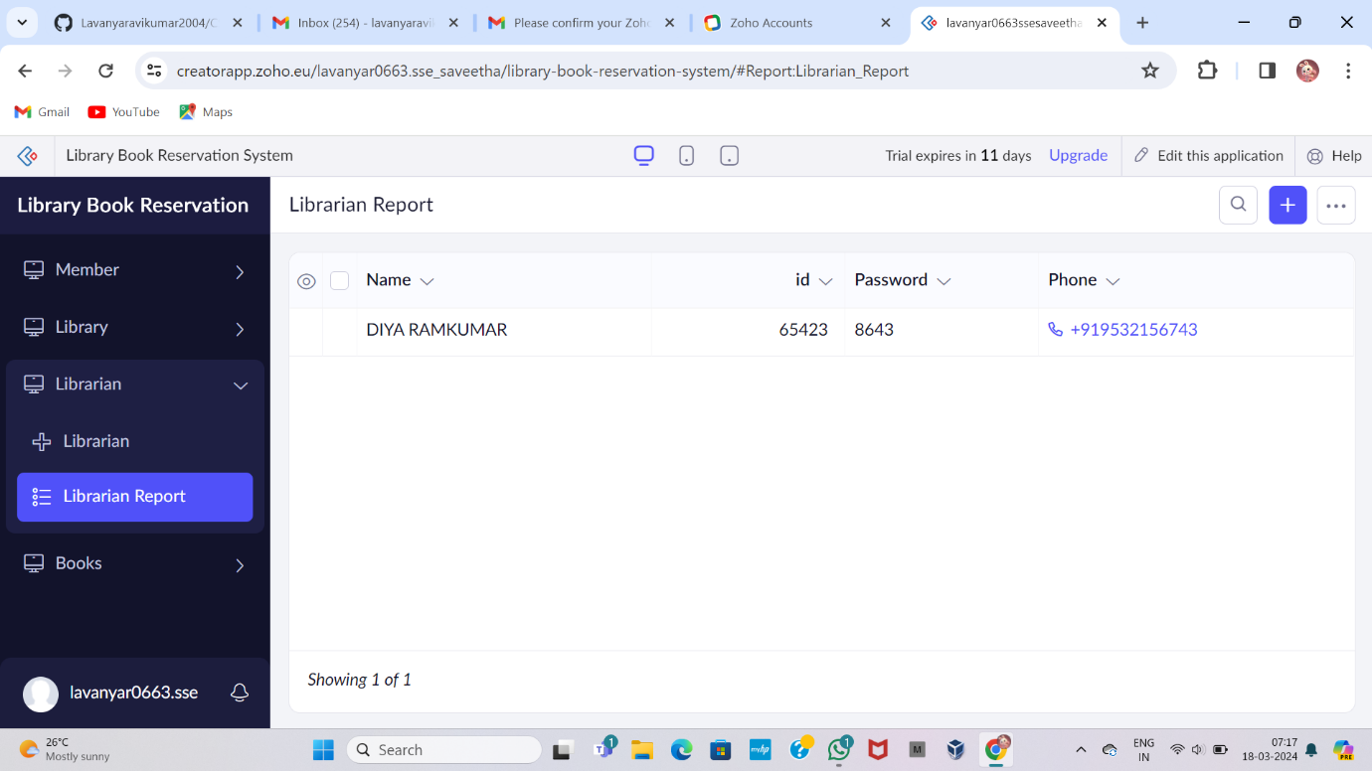

STEP-12 : Display the Books details

